Socials 7 Assessment Review, 2014-15

The socials year-end assessment will primarily examine and provide an opportunity for students to demonstrate the skills we’ve developed and goals we’ve worked towards this year. While there is some content that will need to be understood, this will serve as a backdrop to illustrate skills rather than the be the primary focus of the assessment.

Course Goals:
- To promote a sense of wonder and excitement about history
- To foster critical thinking and inquiry skills
- To refine and use 21st century technology skills in an academic setting
- To improve students’ ability to effectively locate, analyze, and use information and researched material
- To increase students’ abilities to produce effective nonfiction writing
- To develop students’ geographical literacy
- To analyze, evaluate, compare and contrast various aspects and perspectives of history

Format:
Part 1 – Multiple Choice, Matching, True False (40)
Part 2 – Mapping (15)
Part 3 – Short Answers (30)
Part 4 – Essay (15)

Key Terms
On a separate sheet of paper or on your computer write a few notes about each of the following terms. Your goal is not to memorize a definition of each but to understand each term and its importance to our studies. Sometimes putting terms like these on flash cards and quizzing each other is a good way to help jog your memory and develop a thorough understanding of each concept.

Egypt
- Determinative
- Rebus
- Biliteral
- Rosetta Stone
- Papyrus
- Hieroglyphics
- Pharaoh
- Field of Reeds
- Mummy
- Dynasty
- Shemu
- Akhet
- Peret
- Silt
- Cataracts
- Delta
- Pyramid

Greece
- Menelaus
- Theseus
- Minos
- Minotaur
- Agamemnon
- Aegeus
- Ariadne
- Helen
- Dorians
- Priam
- Paris
- Pericles
- Socrates
- Helots
- Philip
- Alexander the Great
- Aristotle
- Homer
- Darius
- Linear “B”
- Palace of Knossos
- Trojan Horse
- Agora
- Polis
- Black Broth
- Athens Council
- Phalanx
- Iliad
- Delian League
- Peloponnesian League
- Democracy
- Monarchy
- Oligarchy

Mapping

You should generally know where the civilizations we studied are and basic map features (i.e., Greece, Egypt, Mesopotamia, North, etc.) and where the civilization you studied independently is.

More specifically you should be able to find the location of:

Ancient Egypt | Ancient Greece
- Modern day Egypt  - Modern day Libya  - Modern day Sudan  - Modern day Ethiopia  - Lake Victoria  - Nile River  - Mediterranean Sea  - The Red Sea  - Upper Egypt  - Lower Egypt  - Nile Delta  - The Great Pyramids of Giza  - Which direction does the Nile Flow? | - Athens  - Sparta  - Troy  - Pella  - Aegean Sea  - Ionian Sea  - Mediterranean Sea  - Crete  - Knossos  - Mycenae  - Peloponnesus Peninsula  - Macedonia  - Persian Empire

Maps

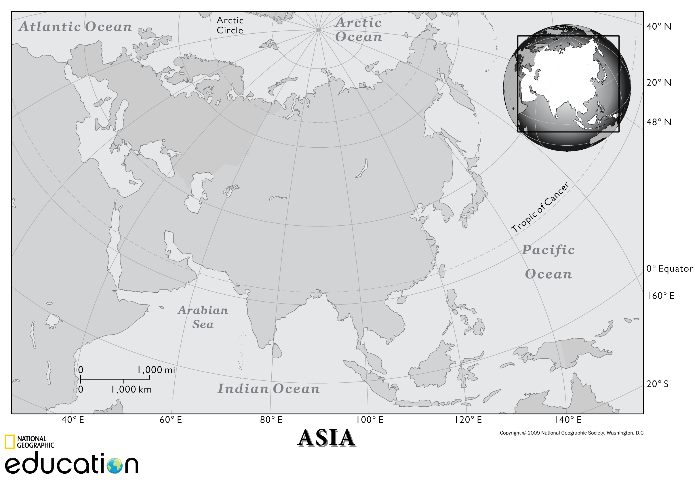

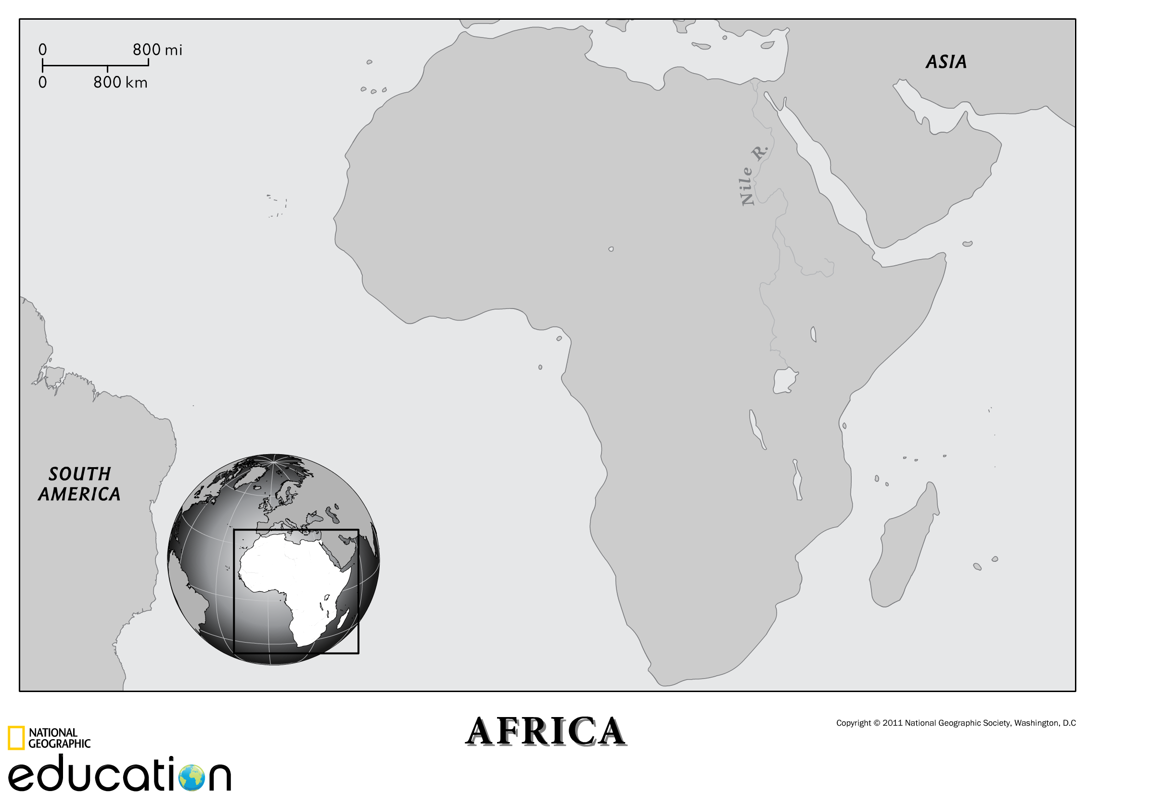

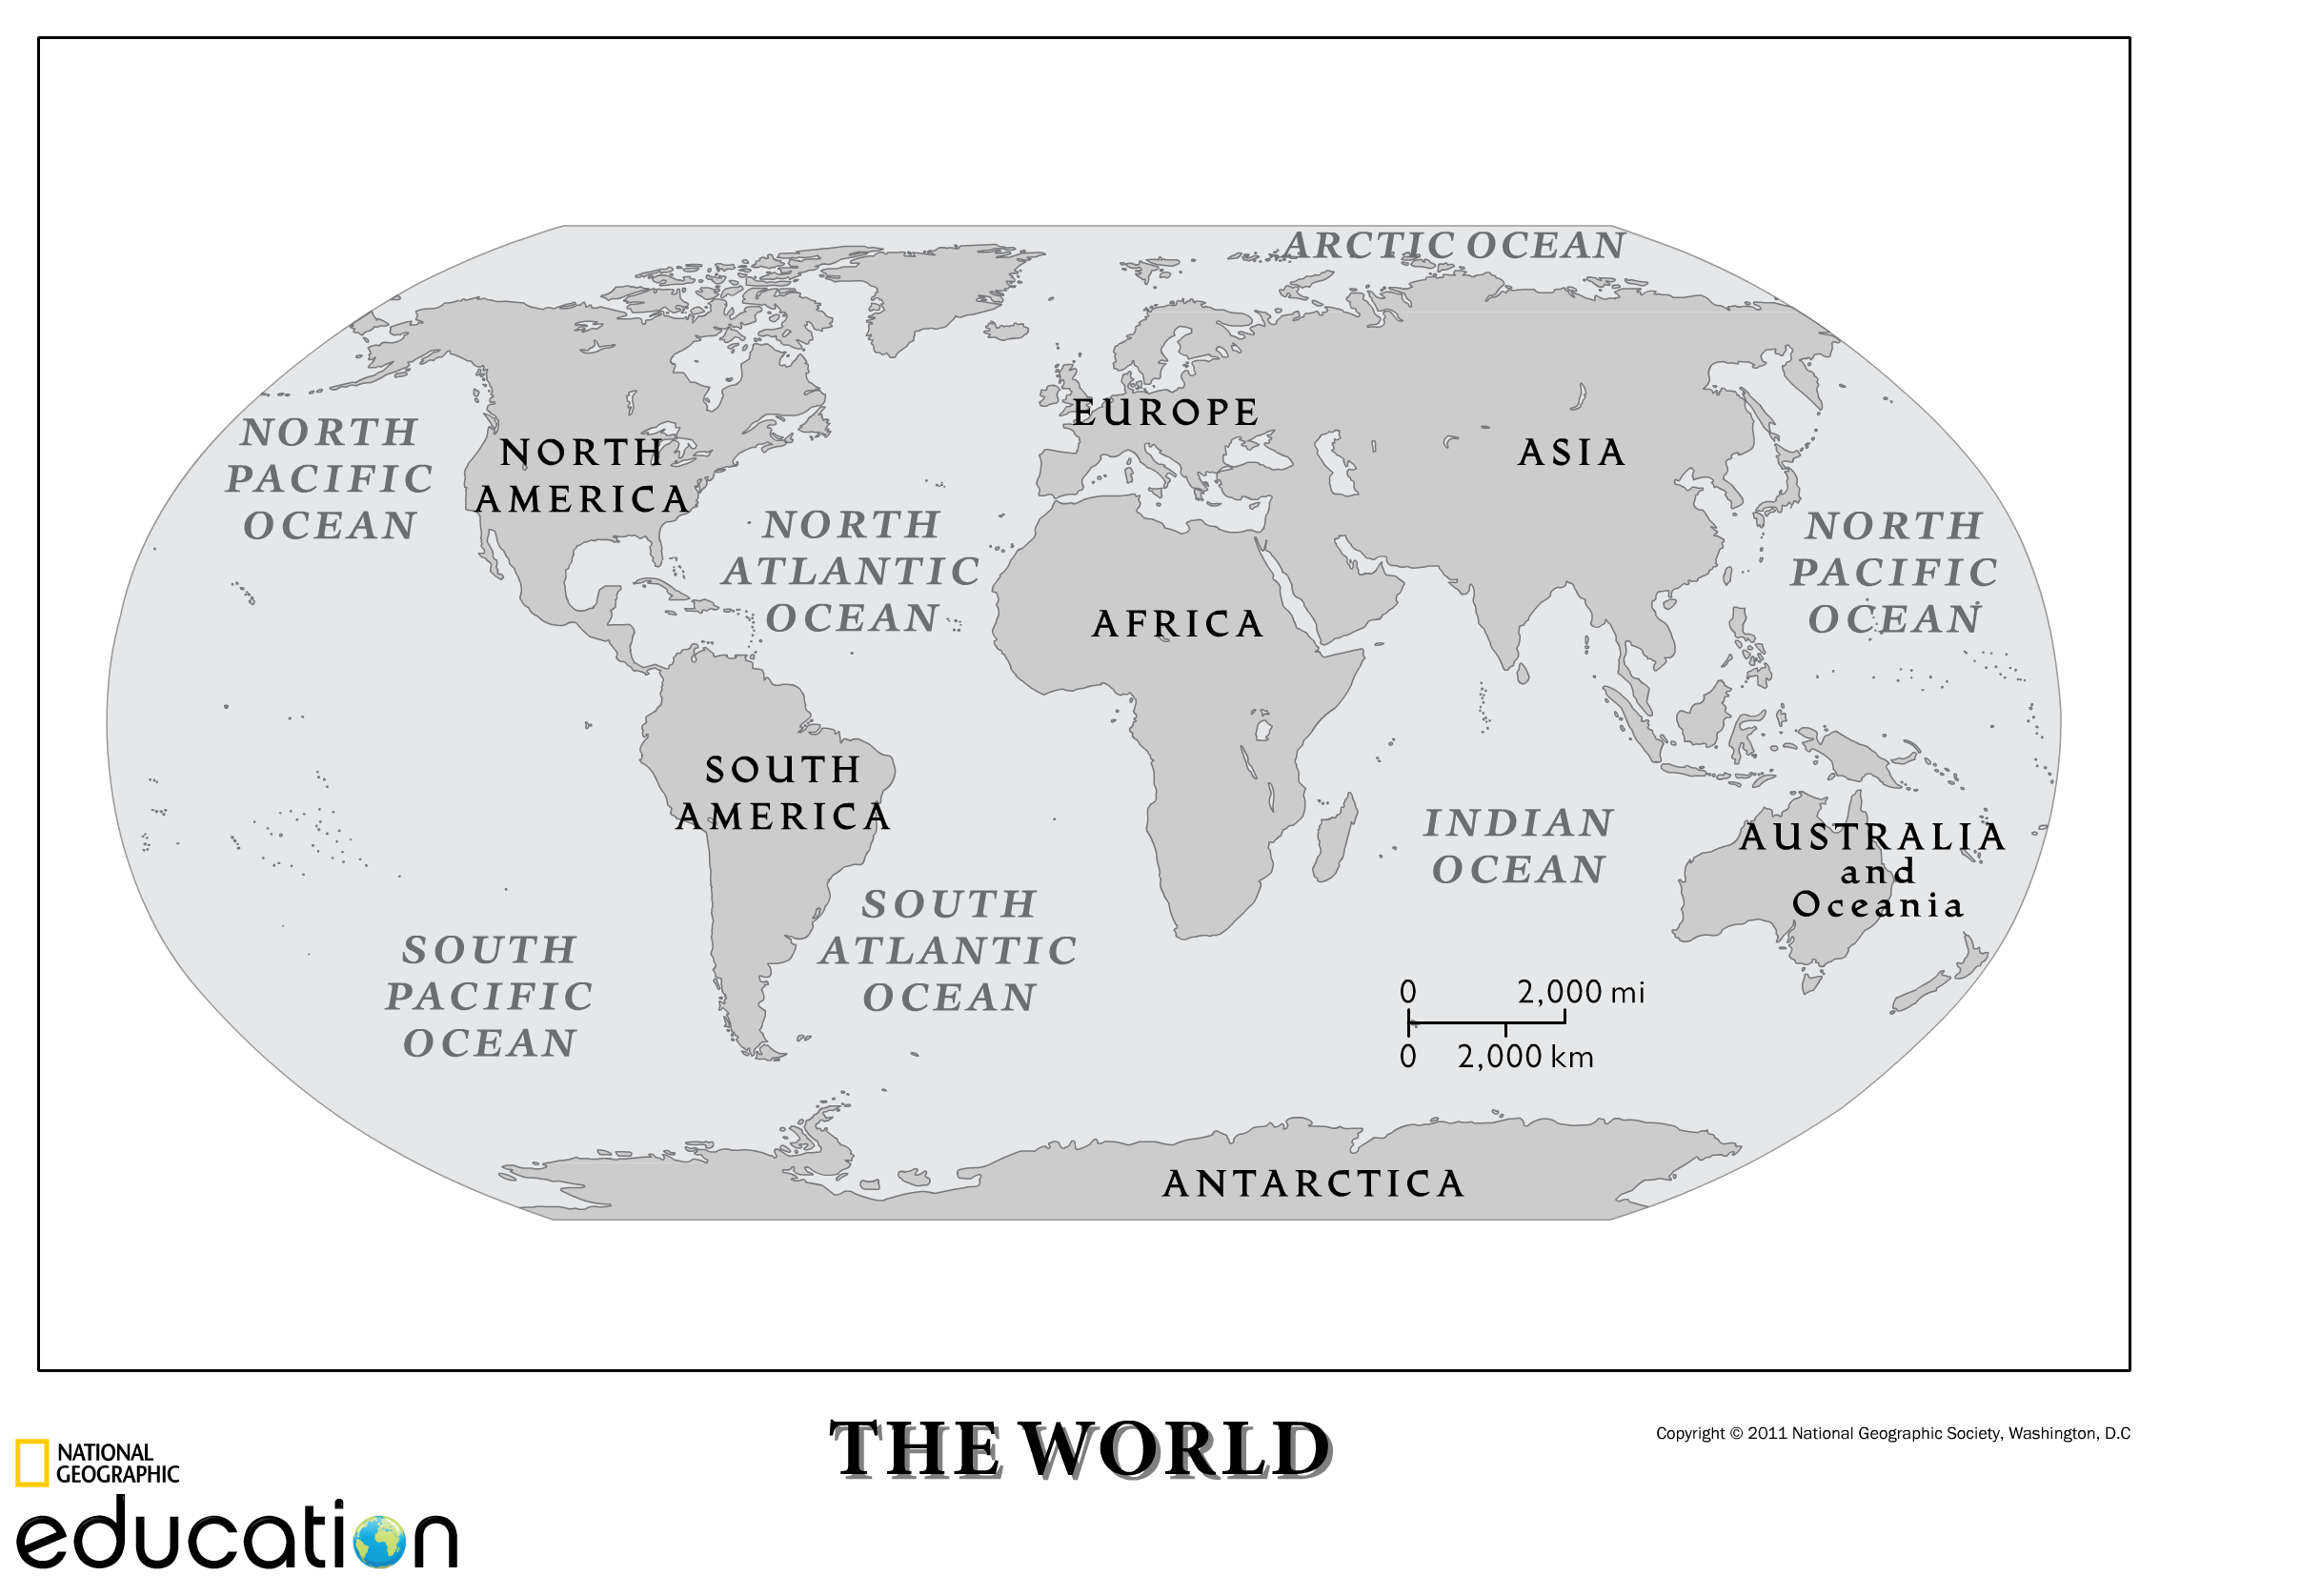

Short Answers - Create answers to the following questions:

Civilization:

- Why and how did civilization begin to develop?
- Briefly describe, and provide an example of, each of the six characteristics of a civilization according to the National Geographic article, “Civilizations”.
- What do you think is the most crucial characteristic and why?

Mesopotamia:

- What is the land between two rivers?
- Why did civilization begin and develop in Ancient Mesopotamia?

Egypt:

- Explain how hieroglyphics are read (i.e., right to left, left to right, top to bottom, bottom to top, etc.).
- What was papyrus, and why was it such an important innovation?
- Outline the process of mummifying a body.
- Explain why you think there were only four female pharaohs.
- Explain what life was like for the peasants in Egypt.
- Why did predictable flooding play such an important role in the life and culture of Ancient Egypt?
- What did the Nile River provide the Ancient Egyptians (hint: there are at least 6 things).
- What is the most interesting time period of ancient Egypt to you and why?
- Why did the Ancient Egyptians have so many gods?

Greece:

- How did geography play a role in the development of the culture of Ancient Greece? (All time periods)
- Explain 3 Theories of downfall of Minoans, 2 theories of downfall of Mycenae
- What was the Legend of the Minotaur
- What was the Legend of Troy (Trojan war, Trojan horse)
- What were the Dark Ages
- How was life different for women in ancient Athens and Sparta?
- Generally explain the Persian and Peloponnesian wars.
- Explain the details of Alexander the Great’s journey of conquest.
- Ancient Persia, in many regards, was more advanced than ancient Greece. Why do you think the history we are told is from the Greek rather than the Persian perspective?

Sample Essay Questions

- It is generally accepted that the development of agriculture and farming is what ends the era of Cro Magnon and begins the era of Ancient civilization. Using examples explain how farming leads to culture.

- Using examples from the civilizations of Egypt, Greece and/or Rome, describe the evolution of government.

- What do you see as the greatest gifts, left behind by the ancient civilizations we have studied? Give reasons and use examples to support your ideas.

- Based on our study of ancient civilizations, what will future humans, thousands of years from now, find interesting, surprising, unique, or foolish about Modern Western Civilization?

- In our study of Ancient Culture we have seen that most cultures grow, flourish for a time, experience a dark ages, and sometimes grow again. What stage do you believe Modern Western Civilization is at now and why?

- If this is the golden age of humanity what makes it so?

- If this is the dark ages of humanity what makes it so?

Notes:

