Homo Sapiens (Cro-Magnon) Resource Package

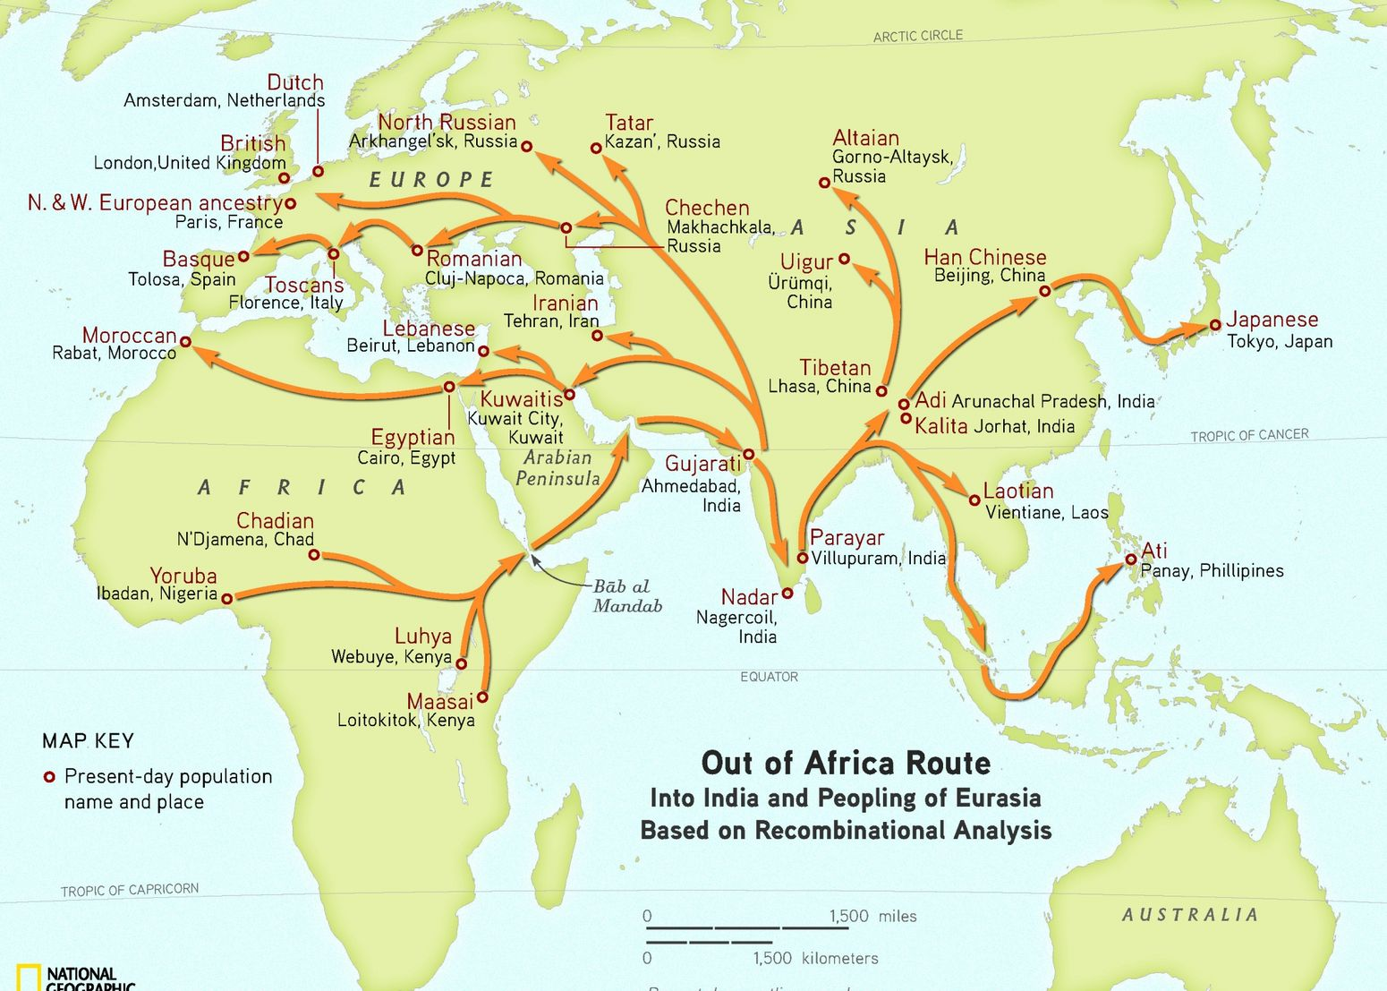
Towards the end of the Ice Age, around 40,000 years ago, Neanderthal people died out and a new type of Homo sapiens with greater skills and ability to reason was moving into Europe. Scientists named this species Homo sapiens. The first anatomically modern humans evolved in East Africa and began leaving the continent around 200 000 years ago. By 30,000 years ago, humans had spread throughout Africa, Asia, and Europe. The local type of humans that lived in Europe around the end of the ice age are now known as Cro-Magnon after the location in France where the first remains were discovered. In 1868, workers who were widening a road cut into a roadside rock shelter known as Cro-Magnon or “big cave.” There they discovered carefully buried skeletons and stone tools. These ancient cave dwellers lived under the rock overhang that was open faced and used the true cave which goes underground for special ceremonies and burials. By 11 000 years ago, Cro-Magnons had crossed the land bridges that were in existence only during the Ice Age to occupy North and South America. Every continent but Antarctica was now populated by humans!

Early homo sapiens and cro magnon people were the first to have almost identically shaped bodies and skulls as modern humans. Their skulls had more rounded brain cases and pointed chins than previous hominids and their foreheads were flat, rather than sloping, and ended in only very slight eyebrow ridges. Their noses and jaws were smaller than previous early humans and contained smaller teeth that were more crowded together. This made their faces fairly straight rather than jutting forward. In addition, based on the position of the larynx, Cro-Magnons were the first of our ancestors to be capable of producing clear speech with a diversity of sounds comparable to our own. This means that they were capable of developing a more advanced language and means of communication. This enabled them to share information, work together, pass down knowledge and traditions, organize hunting and gathering trips, and speak about more complex thoughts, including planning for the future. Many scientists now believe that it was this increased ability to use language that spurred the development of a more advanced culture.

Since Cro-Magnon people lived during the end of the Ice Age, the weather was still cold and unpredictable. Therefore, fire was a vital part of the Cro-Magnon culture. Fire was the only source of heat in the caves or huts during extremely cold winters. Fire was also used to chase game into traps when hunting herds or large mammals, such as the woolly rhinoceros, mammoths, or even predators like tigers. A fire at the entrance to the cave or hut where the Cro-Magnons lived provided protection against wild animals. Fire was the only source of light at night and the only way these prehistoric people had to cook their food.

As these early humans developed, so did their tools. Cro-Magnons altered the flint-bladed hand axes into chisel-like tools called burins. These new tools could be used to split and shape stones and other materials that were softer than stone. The burins led to the invention of a series of new tools and weapons. Awls were created to make better holes in animal hides, bone needles were used to sew more refined clothes, and the first straight-backed knives were created to make cutting an even finer skill. Similarly, because hunting was the most important part of a Cro-Magnon’s life, the development of new and better weapons was continually taking place. Cro-Magnons learned to carve spearheads and blades from bones and antlers, not just stone. Using bone implements, they were able to heat and straighten a crooked shaft. Discovery of the throwing stick enabled a hunter to throw spears farther and faster than before. And around 10,000 years ago the bow and arrow came into use, enabling the hunter to strike many times from a safe distance when hunting dangerous prey. Also, there seems to be some evidence that Cro magnons were able to fall and harvest timber for use in the construction of buildings and water craft.

Since Cro-Magnons had not yet learned to domesticate animals or plant crops, hunting and gathering was still a daily necessity. Hunting provided food and other raw materials the Cro-Magnons needed. Animal hides were used for making clothing, robes, shelters, and bedding that were far more sophisticated than those made by the Neanderthals. After a hunt, the animal was skinned. With pegs the hide was stretched on the ground with pegs with the hair side down. Then it was scraped with special tools to remove all flesh or fat. The pegs would keep the hide from shrinking or curling as it dried. The hide was cured until it was soft and pliable. Then it was cut with stone knives into shapes that were sewn into pants, tunics, and dresses. Holes were bored, and sinew, or animal tendon, was used with a bone or antler needle to sew the clothes together. Cro-Magnon people often stitched little beads of coloured rock or shells onto their clothing for decoration. They also wore necklaces made from stones, shells, fish bones, or bits of eggshell.

Cro-Magnons were very resourceful people and left nothing to waste. Sinew from animals was used to secure shelters, to braid into rope, or to form bow strings. Tusks and large bones from the leg of a mammoth were used to create shelters which were then covered with skins. Cro-Magnons stood the leg bones in mammoth skulls for support because they could not push them into frozen ground. These larger bones were also used as hammers and clubs while smaller bones were used for needles, fish hooks, and jewelry. Antlers and horns were shaped into weapons like harpoons, and antlers that had points with barbs pointing backwards were tied onto spears. Horns and antlers were also made into tools for digging.

With their advanced tool making and planning abilities they were able to forage for wild carrots, beets, onions, turnips, cabbage, celery, fruits, and berries among other foods. Cro-Magnons foraged for wild wheat and other grains as well as for special plants with medicinal properties to make healing teas and poultices. Since the Cro-Magnons had no way to preserve their food, such as nuts, seeds, and fruits, it is likely that they prized food that did not spoil. These could be dried in the sun and eaten during the winter months when the ground was covered with snow. Besides plants, and hunting, it is believed that Cro Magnons also gathered shellfish, eggs, and small animals caught in snares, nets, or nooses made of sinew.

The Cro-Magnons were, essentially, a nomadic people. During the summer months they probably moved from their caves or huts to new areas, since moving from place to place enabled them to find new sources of game and plants. Summer camps also provided an opportunity for different people to get together to share stories, have celebrations, and find mates. Near Soultre, France, the bones of about 100,000 wild horses were found at the base of the cliff. Hunters used the cliff to stampede herds of horses and other animals to their death in an annual hunt. The remains of the hunters’ temporary summer camp covered a large outdoor area. The size of this camp indicates that this annual “drive” was successful because many different family tribes worked together. Because of the vast quantity of bones discovered at this location, archaeologists assume this annual hunt took place for many years. Hence, summertime would have been a time of plenty. The Cro-Magnons probably even had time to relax.

Daily life for the Cro-Magnon people was very difficult. On those rare occasions when there was plenty to eat and the weather was fair, they would probably have been in a festive mood. Remains show that Cro-Magnons enjoyed many celebrations and ceremonies that revolved around a boy’s transition into manhood, hunting, and the seasons. Celebrating and feasting from a good hunt probably involved gathering around the evening fire for all to hear the story about the hunt. It is possible that the story was told through dance with some members of the tribe acting out different parts and others chanting to the dance. Simple drums and percussion instruments have been discovered, showing these early humans enjoyed playing music during their celebrations.

However, the clearest sign of the Cro-Magnons’ advanced culture was in their art. They were probably the first people to discover how to paint, sculpt, carve, and use colour. No evidence has been found of pictures being made by earlier people. The Cro-Magnons carved designs in their tools and decorated their clothing with jewelry. They carved the first sculptures of animals and rounded female figures out of bone, ivory, antlers, and stone. Most scientists believe these figures were totems, or god figures, to ask for good fortune when hunting and gathering and to pray for more children to be born into the tribe.

These sculptures and amazing paintings were found in the deep recesses of underground caves. The earliest paintings consisted of hunting scenes and were most likely painted by men. Pictures included horses, bison, reindeer, and mammoths. These pictures have offered scientists clues about what prehistoric animals looked like. Often the Cro-Magnons painted spears in the paintings, showing that a hunt was taking place. However, few plants or people are found in the early paintings. Sometimes an artist would put his/her hand on the rock and blow paint around it with a reed. The hand symbol might have been used as magic since it was the maker of tools, or perhaps it was a prehistoric way to “sign” the picture and identify the painter. Paints were made by grinding coloured rocks into powders and mixing them with animal fat. Colours included shades of red, orange, brown, black, and yellow. Paints were stored in hollow bones with lumps of fat in the ends. Brushes were made from animal hair tied to small bones. Sometimes they applied the paint with their fingers or used little pads of fur or moss.
The first cave paintings were found purely by accident. In 1879 a young girl and her father were exploring a cave in northern Spain where some stone tools had been found. Since many of the passages were narrow, only the young girl was able to reach a chamber that had never been seen in modern times. Inside, on the ceiling of the cave, she saw a herd of life-size bison. When her father saw the paintings he told others. However, they thought the paintings were a hoax, and so the cave was closed up and forgotten. Over the next 30 years other discoveries in France led archaeologists to reopen caves in Spain. It was discovered that the paintings in the European caves were created between 12,000 and 35,000 years ago. The colours were still vivid and bright. Many other cave paintings have been found throughout the world since then, including the world famous Lascaux Caves in France. Although the original cave was closed in 1963 to preserve the paintings, a replica using the same techniques of painting can be visited today.

Cro Magnon 1 (first fossil)
http://humanorigins.si.edu/evidence/human-fossils/fossils/cro-magnon-1

Homo Sapiens info
http://humanorigins.si.edu/evidence/human-fossils/species/homo-sapiens

Amazing story of human migration
https://genographic.nationalgeographic.com/human-journey/

Watch the video?
https://genographic.nationalgeographic.com/human-journey/

Great human migration article
http://www.smithsonianmag.com/history-archaeology/human-migration.html

Cro Magnon tools
http://www.kidspast.com/world-history/0020-cro-magnon-tools.php

List 3 inventions, or ways of life, that were unique to Cro Magnon, that allowed them to evolve and progress faster than any previous species:(3)

Why was the development of an advanced language important in advancing the culture of early people?(6)

